**SOFTENING**

*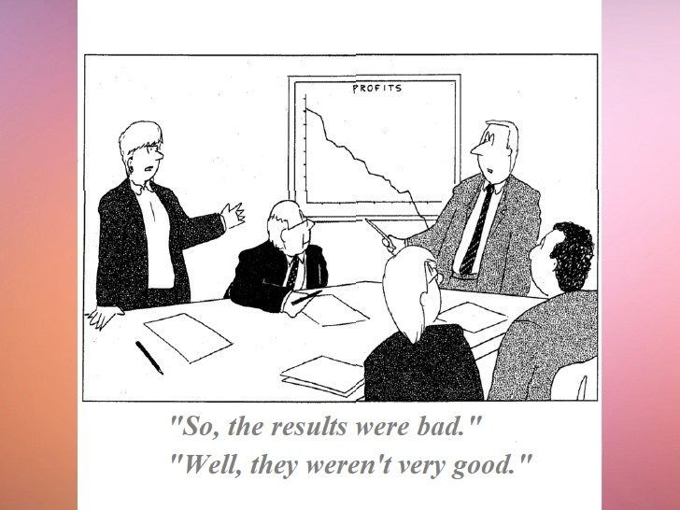****1.*** *Look at the cartoon. How does the presenter’s reply sound compared to the first statement? What effect do you think it produces?*

***2.*** *Discuss the questions with a partner.*

* When do people need to soften their messages?
* Are you a direct person in everyday life?
* How often do you need softening at work? When was the last time you needed to soften your words?

***3.*** *How would you soften the messages below? Compare your answers with a partner.*

1. This is a bad idea. ____________________________________________________
2. We can do this, but this will be expensive. ____________________________________________________________________
3. We can't do this. It's too difficult and you asked us too late. ____________________________________________________________________
4. I don’t want Nick on my project. He can’t code. ____________________________________________________________________

***4.*** *Watch four extracts, answer the questions and fill in the gaps in the scripts.*

[Extract 1](https://youtu.be/GMRjIlG19DU?t=11m6s) [11:06 to 11:25]

* What is the presenter describing?

*Watch the extract again.*

* How direct is the presenter when describing the icons and the dots? Fill in the gaps as you listen.

You can see that once you go beyond the menu to the actual bar icons, in particular the mood and share icons, they’re also _________ non-standard. They’re __________ dark. The overflow menu item itself looks a lot like the standard overflow menu but isn’t quite it. It’s too dark. The dots are ________ big.

[Extract 2](https://youtu.be/gX0n4JUl18g?t=17m37s) [17:37 to 18:18]

* What’s the presenter’s opinion on timeline-based models?

*Watch the extract again*.

* How direct is the presenter when saying that timeline-based models aren’t a good choice? Fill in the gap as you listen.

So a timeline isn’t very efficient, if you’re trying to build these longer interactions. Maybe just a show of a small thing, and I think that's the most obvious reason that that ________________ ___________________model to pick for these new tools.

[Extract 3](https://youtu.be/rP-kjrx9CRE?t=44m11s) [44:11 to 44:25]

* What can be used as a cache, according to the presenter?

*Watch the extract again.*

* How intuitive is it to use the data store to cache stuff? Fill in the gap as you listen.

So there's one final spot where it actually sometimes makes sense to cache stuff, and this ____________sort of unintuitive. You can actually use the data store as a cache.

***5.*** *Study the mind map and answer the following questions:*

a) What lexical means (particular words) do we use to soften a message? Underline them.

b) How can we soften a message grammatically? Underline the grammar structures.

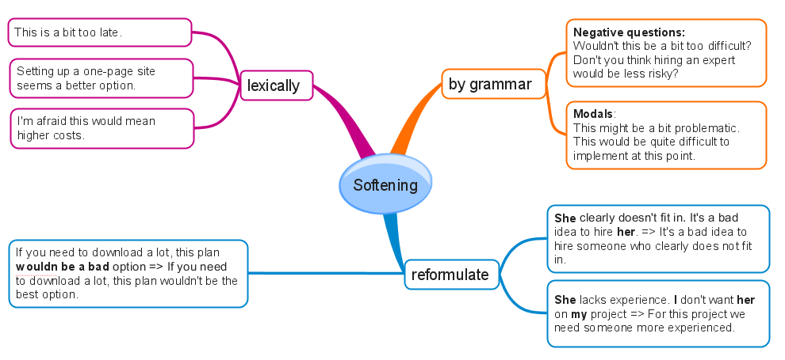c) Do you agree that reformulating is the most difficult way of softening? Why?

***6.*** *Rewrite the sentences below making them sound softer. You may need to make changes to the sentences.*

*A. Lexically. Use “a bit/a little (too)”, “I’m afraid [this would mean] ”*

* We can do this, but this will be expensive. _______________________________________________________
* The task’s too difficult and you asked us late.

_______________________________________________________

* We can do this, but we’ll need to make lots of changes. _______________________________________________________

*B. Lexically. Use “seem”*

* Using the ABC component is strange idea. Let’s use the DEF one.

_______________________________________________________

* There are lots of bugs in this code.

_______________________________________________________

* This interface isn’t user friendly at all.

_______________________________________________________

*C. Grammatically. Use negative questions with “wouldn’t” , “don’t you think”*

* This will be unrealistic considering how much time we have.

_______________________________________________________

* It will be better if we extend the deadlne.

_______________________________________________________

* The buttons will look too large.

_______________________________________________________

*D. Grammatically. Use modals (might, may, would)*

* There will be problems with text input.

_______________________________________________________

* If we don’t hire another person, we won’t get this done in time.

______________________________________________________

* This feature will be difficult to implement at that stage.

_______________________________________________________

*E. Reformulate*

* That’s the craziest idea I’ve ever heard.

_______________________________________________________

* He constantly makes mistakes and works too slow.

_______________________________________________________

***7.*** *Rewrite the highlighted sentences below using the words in brackets.*

**(a)** - We could change the site menu.

- Yes , but this will confuse the users. *(wouldn’t, a bit)*

__________________________________________________________________

**(b)** – Let’s launch a new product in September.

- No, let’s wait until next year. *(think, might, better)*

__________________________________________________________________

**(c )** - We could absolutely redesign the site.

- The problem is, it will be difficult for people to get used to this new look. *(might, a bit)*

__________________________________________________________________

**(d)** - It’s a bad idea to change the design at this point. This will cost a lot. *(afraid , best, would)* __________________________________________________________________

**(e)** The figures in the report that you sent us are wrong. *(seem / reformulate)*

__________________________________________________________________

**(f)** - Let’s change the design again.

- This will cost a lot. *(modal, negative question, a bit too…)*

__________________________________________________________________

***8.*** *Work with a partner. For each of the situations below, write 2 sentences that you could say if you faced it. Be direct.*

1. The customer requested a feature that conflicts with the previous requirements.
2. Your team is running behind schedule and is likely to miss the deadline.
3. The code that you were asked to look at is full of bugs.

*Take it turns to read your sentences to your partner. Soften your partner’s sentences so that they are less direct.*